Bluetooth USB Adapter

Works with Bluetooth Compliant devices including

Notebook,PDA, Handheld PC, Digital Camera,

Printer,and Mobile phone.
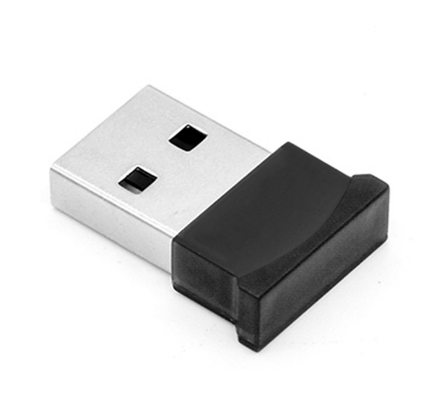
BT-USB-M1

Discrete Bluetooth Connectivity
One of the most compact and stylish Bluetooth USB on the market today, the Dynamode BT-USB-M1 is your ideal BluetoothTM connectivity solution for Notebook, PDA and any other Bluetooth device.
Its compact size allows permanent fixture to your Notebook for example, even when transporting to and from its holdall. Even with its compact design, the BT-USB-M1 allows full BluetoothTM version 2.00 specification with the ability to transmit up to 3Mbps data up to around 100 metres in from a similar Class-1 compliant device. Ideal for WindowsTM and MAC OS XTM, the BT-USB-M1 features class-leading, fully Plug n' Play chipset with a low power design, to keep you up and running for longer.
Also ideal for BluetoothTM PAN (personal area networking), VoIP and BluetoothTM audio applications.

Features
- Ultra compact design - ideal for permanent fixture to a Notebook
- Up to 3Mbps BluetoothTM data speeds
- BluetoothTM Version 2.00 and Version 1.2 specification
- Class-1 compliant - up to 100 metre range
- Plug n' Play USB2.00 interface
- Bundled BluetoothTM utilities
- Supports VoIP, Data, Audio, PDA and Smart Phone
- Ideal for WindowsTM
- Ideal for MAC OS X (10.5.x or higher)

